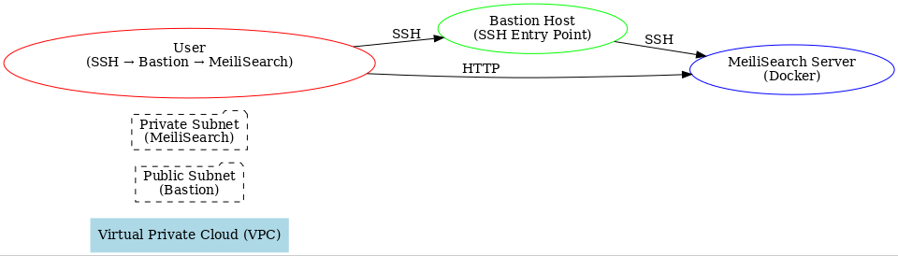.

provider "yandex" {
cloud_id = "your-cloud-id"
folder_id = "your-folder-id"
token = "your-oauth-token"
}

resource "yandex_vpc_network" "main" {
name = "main-vpc"
}

resource "yandex_vpc_subnet" "public" {
name = "public-subnet"
zone = "ru-central1-a"
network_id = yandex_vpc_network.main.id
v4_cidr_blocks = ["192.168.1.0/24"]
}

resource "yandex_vpc_subnet" "private" {
name = "private-subnet"
zone = "ru-central1-a"
network_id = yandex_vpc_network.main.id
v4_cidr_blocks = ["192.168.2.0/24"]
}

resource "yandex_compute_instance" "bastion" {
name = "bastion-host"
platform_id = "standard-v1"
zone = "ru-central1-a"

resources {
cores = 2
memory = 2
}

boot_disk {
initialize_params {
image_id = "fd87hqufg90abcd"
}
}

network_interface {
subnet_id = yandex_vpc_subnet.public.id
nat = true
}

metadata = {
ssh-keys = "your-ssh-key"
}
}

resource "yandex_compute_instance" "meilisearch" {
name = "meilisearch-server"
platform_id = "standard-v1"
zone = "ru-central1-a"

resources {
cores = 2
memory = 4
}

boot_disk {
initialize_params {
image_id = "fd87hqufg90abcd"
}
}

network_interface {
subnet_id = yandex_vpc_subnet.private.id
}

metadata = {
ssh-keys = "your-ssh-key"
}
}

resource "yandex_vpc_security_group" "bastion_sg" {
name = "bastion-sg"
network_id = yandex_vpc_network.main.id

ingress {
protocol = "TCP"
description = "Allow SSH from anywhere"
port = 22
v4_cidr_blocks = ["0.0.0.0/0"]
}
}

resource "yandex_vpc_security_group" "meilisearch_sg" {
name = "meilisearch-sg"
network_id = yandex_vpc_network.main.id

ingress {
protocol = "TCP"
description = "Allow SSH from Bastion"
port = 22
v4_cidr_blocks = [yandex_vpc_subnet.public.v4_cidr_blocks[0]]
}

ingress {
protocol = "TCP"
description = "Allow HTTP from Bastion"
port = 7700
v4_cidr_blocks = [yandex_vpc_subnet.public.v4_cidr_blocks[0]]
}
}

